Asia Fisher
Studio Research

Year 2469
Our human race is slowly declining, increasing our environments stability through time. The world is ending, the sun will expand its horizon to our surfaces and then consume Earth as we know it. Yet, we find there to be only 6 human beings left to survive during this detinating time. These individuals are located within Rack City Creek, a nudist creekside.
These individuals have forgotten the english language and decided to speak an unknown language. This language is depicted through grunts and moans, most of which are born from sexual intimacy.
The six individuals who remain in this area do not like to be photographed, since they do not understand what a camera is or how they’re involved in the photograph. Yet, we have taken photos of the Rack City Creek, where they find their home to be located. 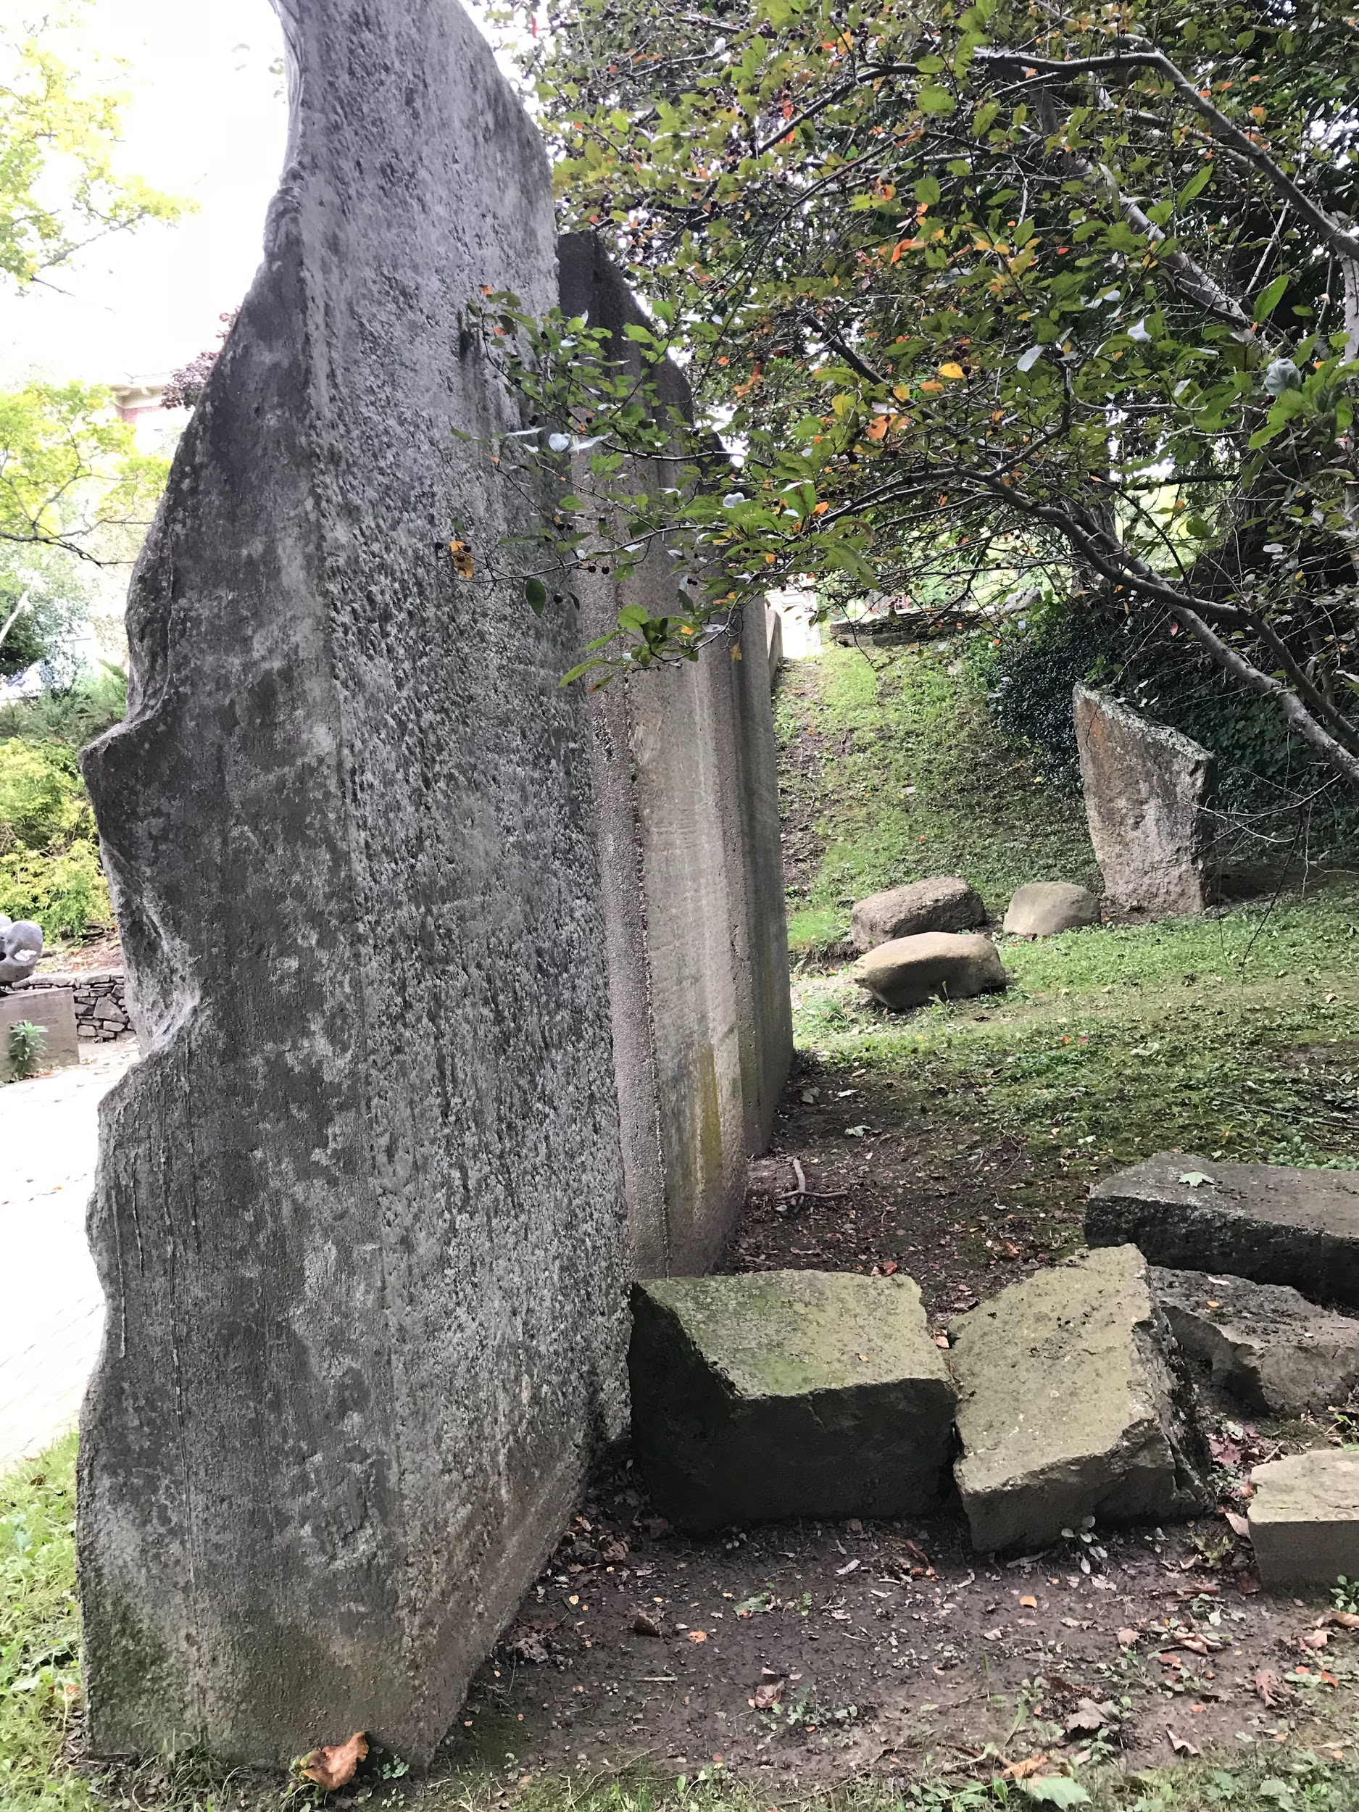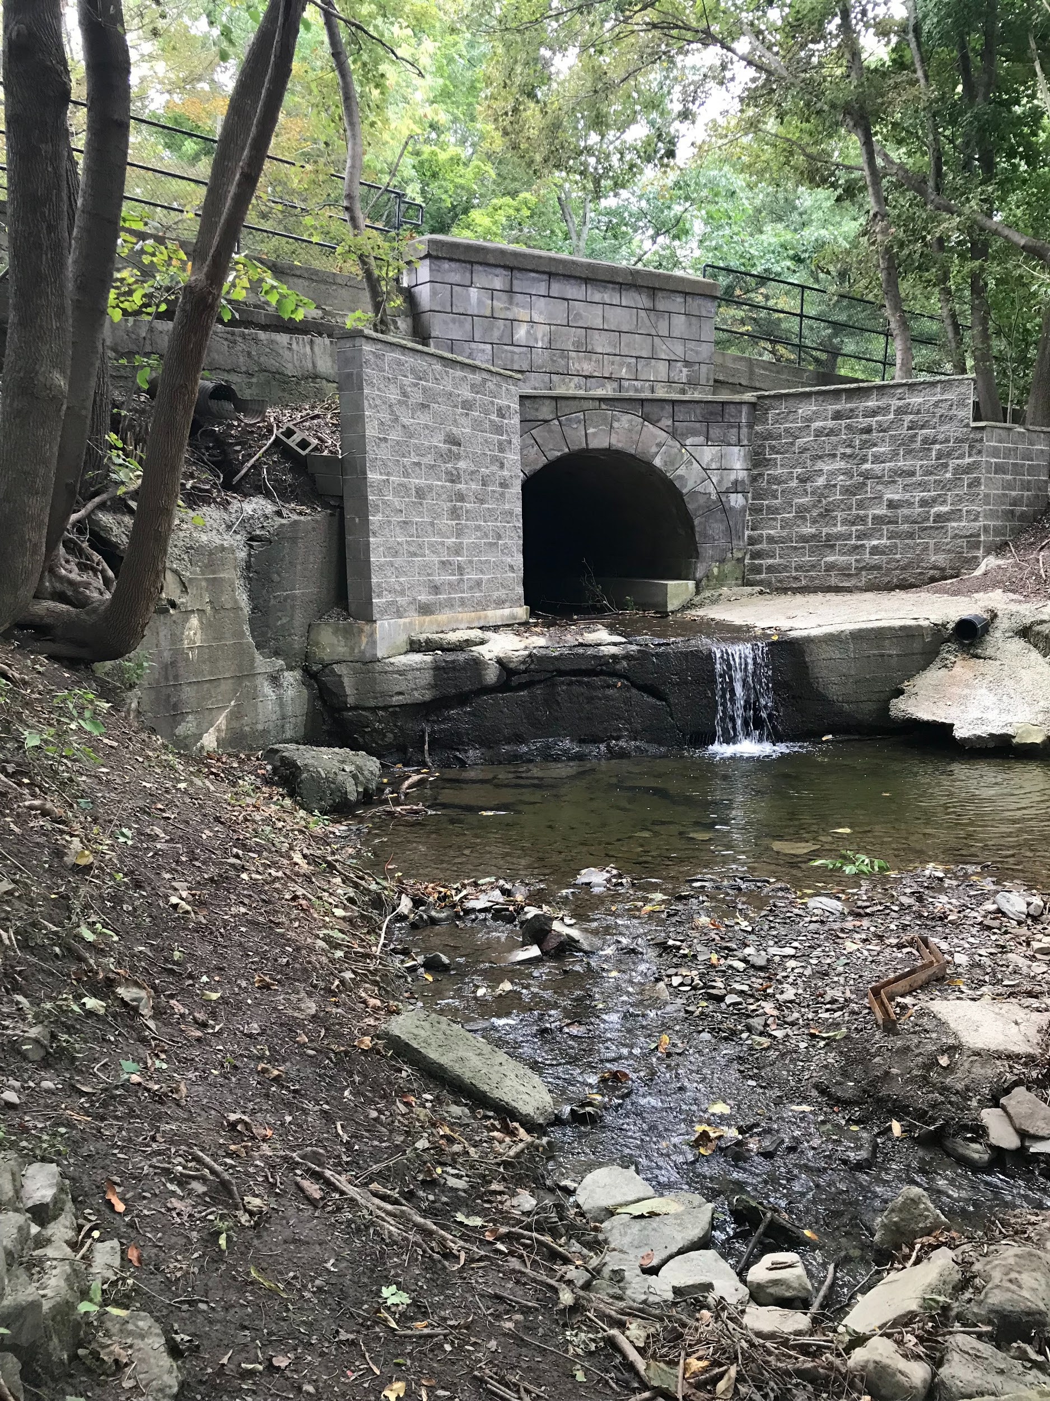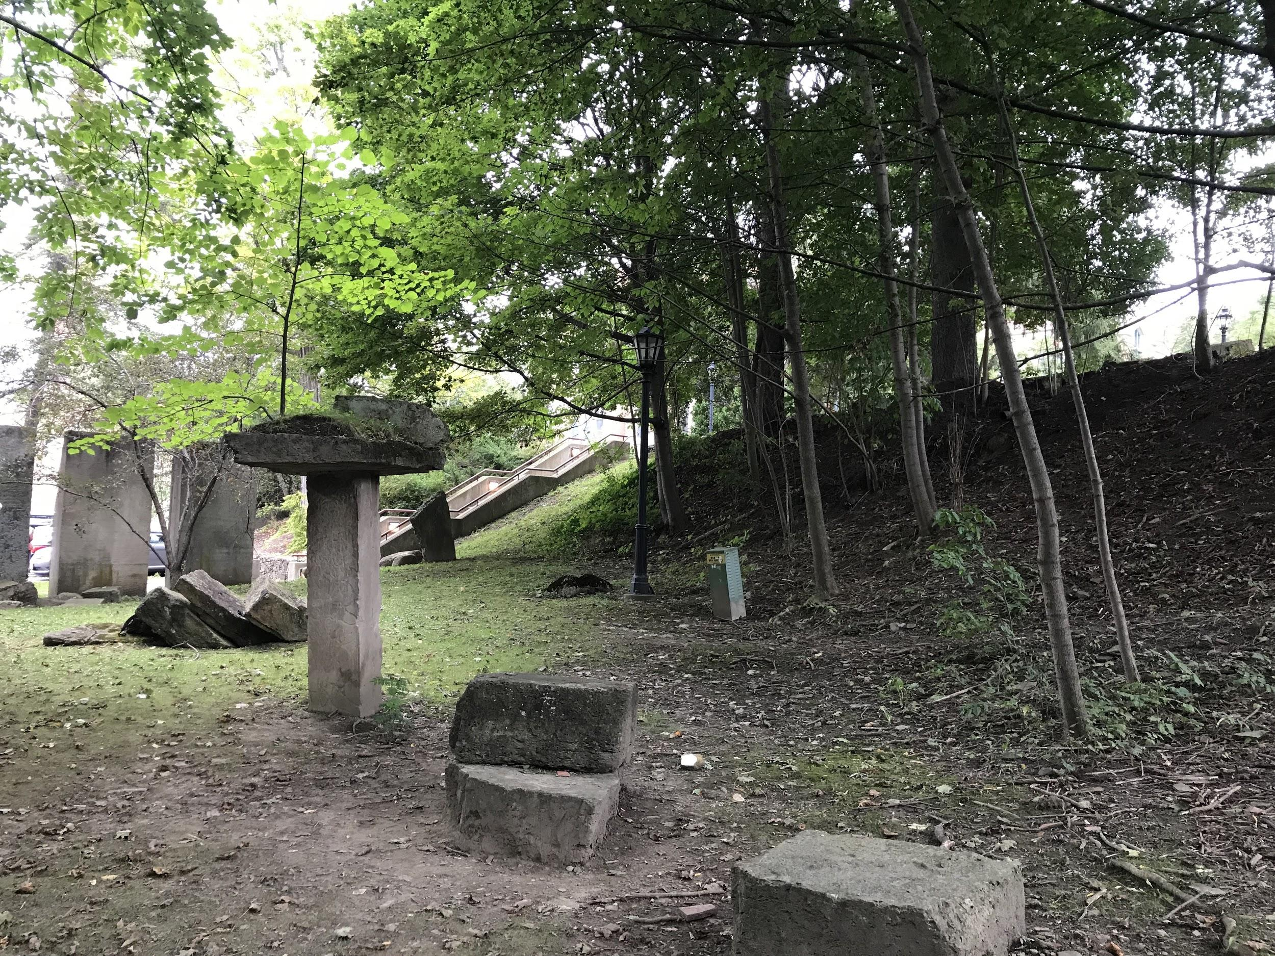
The Rack City Creek is divided into two sides, for one there’s a green field for which they sleep and use as a common area. In addition there’s the tunnel which provides them with water to bathe in and drink. The food they find is normally tree animals of which they hunt down. They use the rocks on the ground, around the three pillars, in order to start fires and for building objects for their own visual pleasures. These individuals have no recollection for their previous life since the virus broke out and demolished more than 80 percent of human population. The United States government was forced to produce a vaccine which only enlarged the side effects of this virus, and caused a massive outbreak for human death, deprivation of memories, conscious, lack of understanding, in addition to a backtrack to indigenous lifestyle.
This Rack City Creek is lost location, for most of the world's population has died off into oblivion and eventually the world will fall into the fateful hands of the sun. 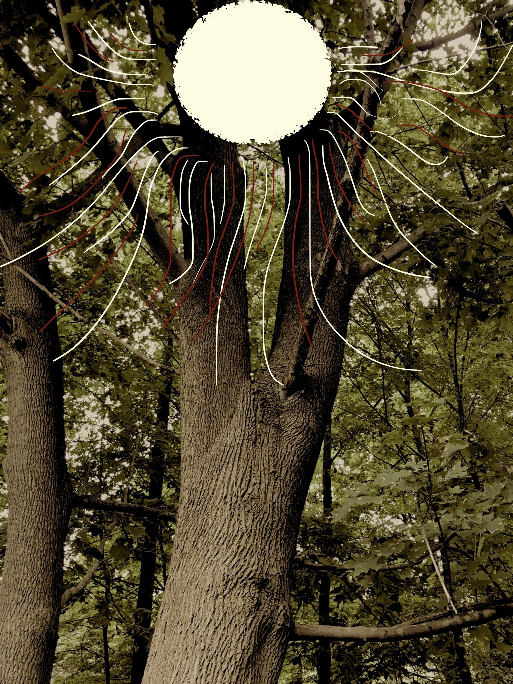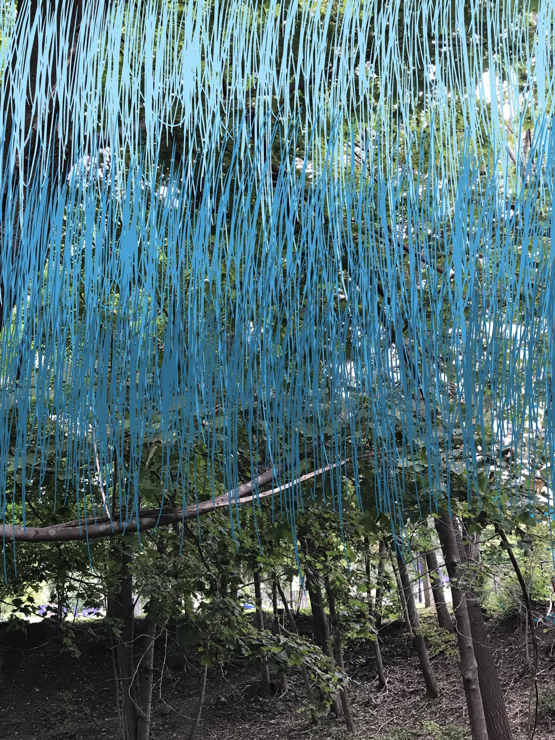

The photos above represent the sun’s deadly rays, in addition to to the poisonous rain which burns the skin immediately after impact. Thankfully, Rack City Creek have coverage from trees which densely populate the area. The only place rain collects is in the creekbed, which means these six individuals cannot drink or bathe until that water has been purified by its natural cycle of movement.
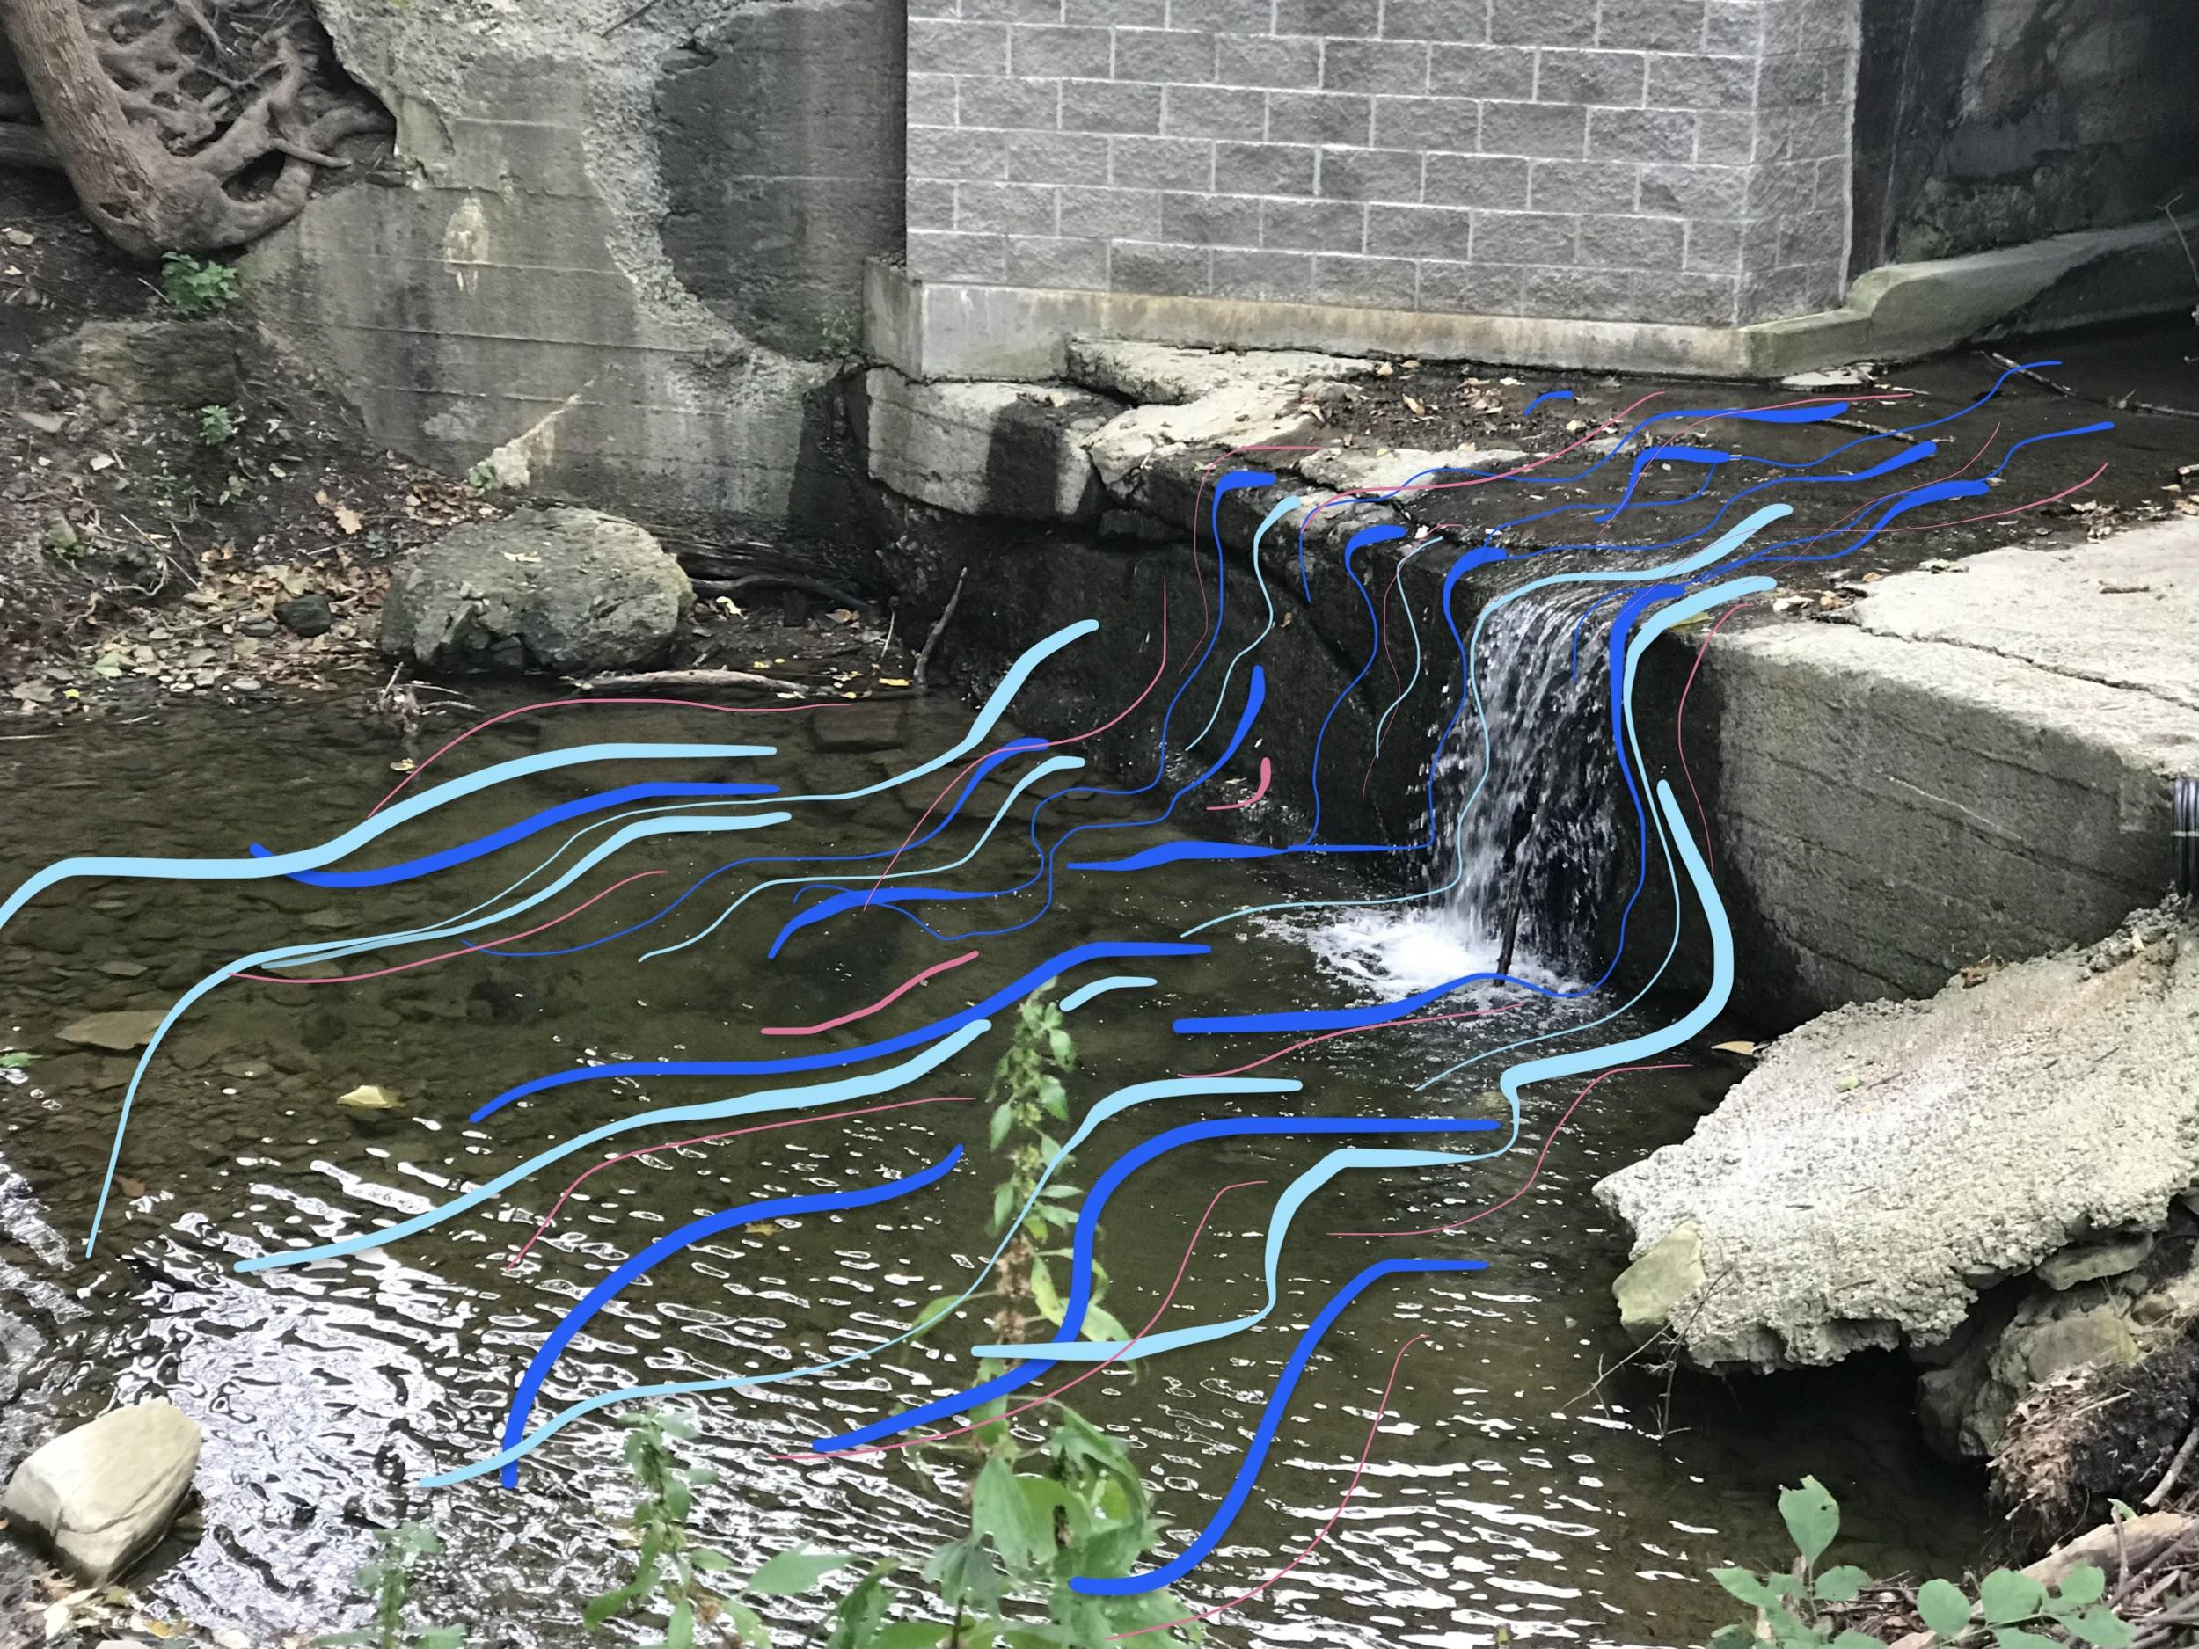
The 6 individuals left at the Rack City Creek are the remainders of humankind, and soon to be destructed by the external environment they seek safety from.

